**Sort Algorithms**

**Bubble Sort:**

Bubble sort is a sorting algorithm that compares two adjacent elements and swaps them until they are in the intended order.

**Explanation:**

If we magic that we want to sort elements in ascending order, we need to follow three steps which is:

1. As we know bubble sort it is start from the first index, so, firstly it will compare first element with the second element.
2. If the first element is greater than second element it will swapped.
3. Compare second element with third element, if the second element it is greater it will be swapped if they are not in order.
4. The above process goes on until the last element.

**Example:**

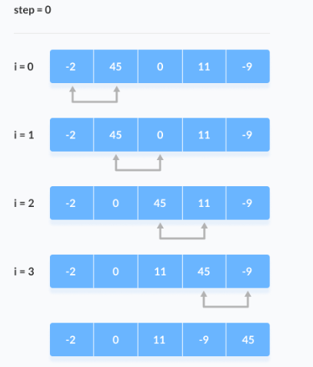

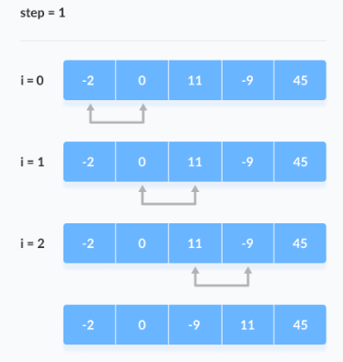

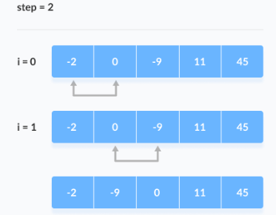

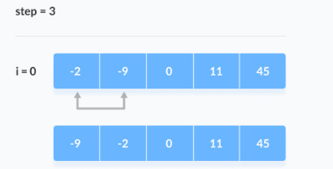

**Python Code:**

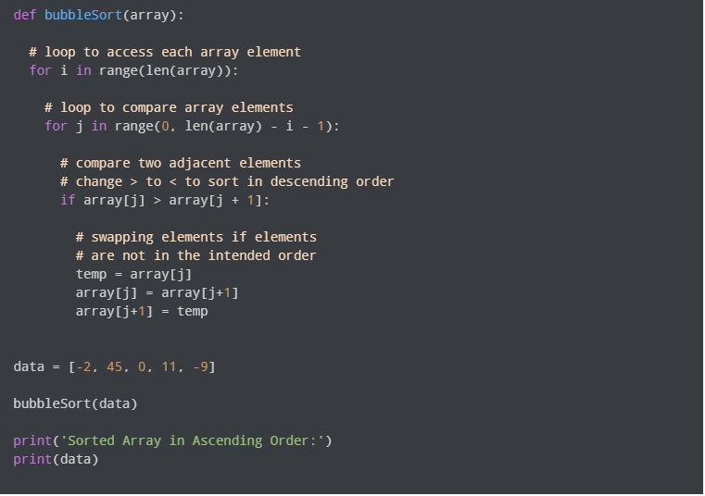

**Selection Sort:**

Selection sort is a sorting algorithm that selects the smallest element from an unsorted list in each iteration and places that element at the beginning of the unsorted list.

**Explanation:**

If we magic that we want to sort elements in a list, we need to follow three steps which is:

1. Set a first element as minimum.
2. Compare minimum element with second element, if the second element was smaller than minimum assign it as minimum.
3. Compare third element with minimum, if the third element was smaller than minimum assign it as minimum.
4. The above process goes on until the last element.

**Example:**

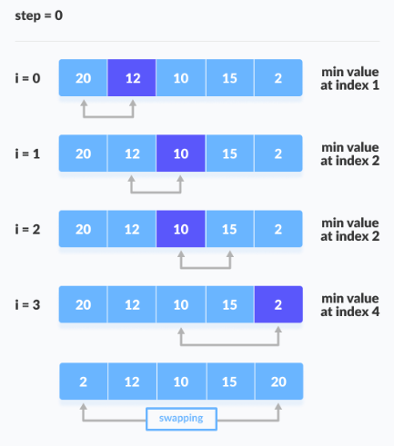

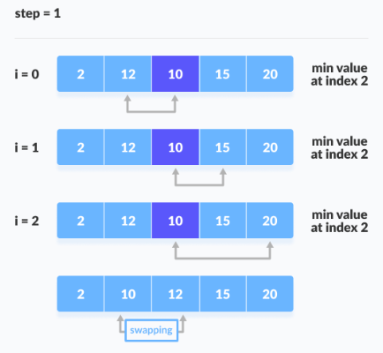

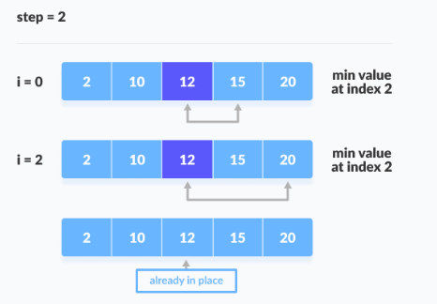

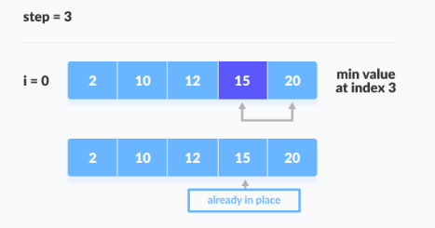

**Python Code:**

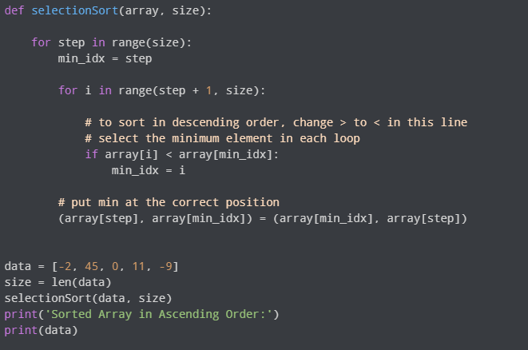

**Quick Sort:**

Quicksort is a fast sorting algorithm that works by splitting a large array of data into smaller sub-arrays.

**Explanation:**

If we magic that we want to sort elements in a list, we need to follow three steps which is:

1. **Pick:** Select an element.
2. Divide: Split the problem set, move smaller parts to the left of the pivot and larger items to the right.
3. **Repeat and combine:** Repeat the steps and combine the arrays that have previously been sorted.

**Example:**

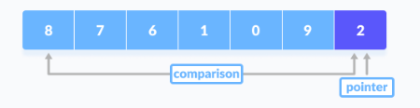

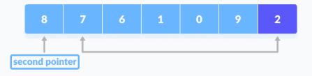

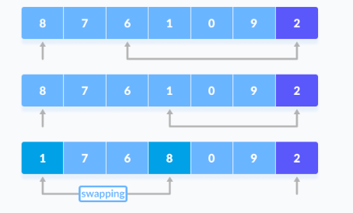

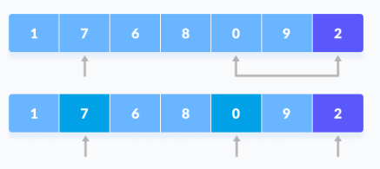

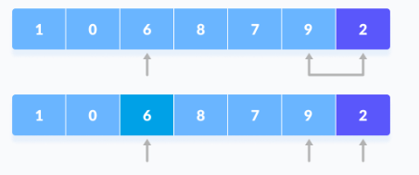

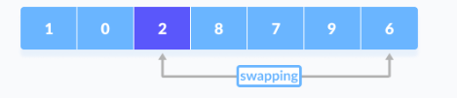

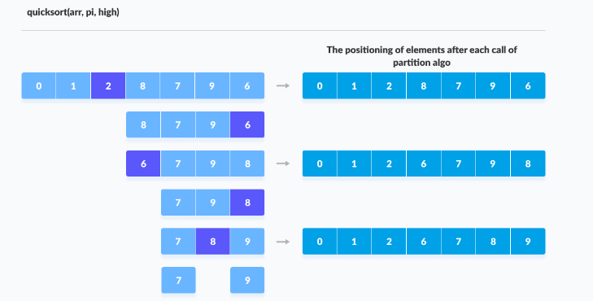

**Python Code:**

